Master Entrance Exam

**Programming**

1. Write an equivalent 8086 assembler program for the following Pascal sequence:  
  
a := 0  
for a := 0 to 9 do  
begin  
 z := x;  
 x := x + 1;  
end;

2. Draw an algorithm that reads two natural numbers N and M, and calculates and prints the sum of all even numbers between N and M, excluding N and M. For example, if the input is N=8 and M=15, the output should be 36, because 10+12+14=36.

3. Determine the output of the algorithm shown in the diagram below, given the input number N=6.

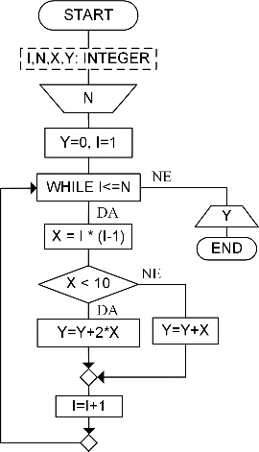

4. Write a program in C or Pascal that takes a list of integers as input and constructs an ordered list without duplicates. Each number appears only once, at its first occurrence.

5. Write a program in C or Pascal that takes a list of integers as input and constructs an ordered list without duplicates. Each number appears only once, at its last occurrence.

6. Write a function in C/Pascal/C++: `void depth(BinaryTree T, int k)` which prints the labels of all nodes in a binary tree at depth `k`. For example, if `k = 2` and the tree $b←a→((d→f)←c→e)$, the function prints: d e.

7. Implement the following classes in C++. Each class should be equipped with the necessary constructors and a destructor to ensure safe and correct usage. The Time class represents a point in time using two long integers: the date, in the format yyyymmdd (e.g., 20230929 for September 29, 2023) and the time, in the format hhmmss (e.g., 190000 for 19:00:00). Assume the default value is September 29, 2023 at 19:00:00. You are not required to validate the input format. The Time class should:

1. Support comparison with another time object, returning a value less than 0 if it is earlier, 0 if it is equal, value greater than 0 if it is later
2. Provide a formatted output in the form: dd.mm.yyyy (hh:mm:ss).

The Event class contains time object representing when the event occurs and string that describes the event. The event should:

1. Allow access to both time and description
2. Be printable in the format: time|description.

The Journal class contains string representing the owner's name, collection of Event objects, sorted in non-decreasing order of time. The journal is initially empty, but supports adding events individually and should be printable with the owner's name followed by the list of events, each on a new line.

Write a C++ program that creates a journal, adds a few sample events and prints the complete journal to standard output. You may use fixed values for demonstration — no user input is required.

**Databases & SQL**

8. Given the relational schema:

Clinet(JMBG, Name, Age, Address)  
Hotel(HID, Name, YearBuilt, RoomCount)  
Room(Number, HID, RoomTypeName)  
RoomType(Name, BedCount)  
Rental(ID, JMBG, HID, Number, Days, Amount)

Write SQL queries to:

1. Find clients who rented rooms in at least 3 different hotels.
2. Find hotels where all rooms are double rooms.
3. Find hotels where every client has rented at least once.
4. Find rooms rented only by clients older than 60.
5. Find the client who has rented at least two rooms in every hotel.

9. What will be the results of the following queries on the Gradilište and Opština relations?

a) SELECT * FROM Gradiliste WHERE vrijednost>640000 and opstinaID=2

b) SELECT g.naziv, o.naziv, g.vrijednost FROM Gradiliste g, Opstina o WHERE g.opstinaID=o.opstinaID AND g.vrijednost>450000 AND o.opstinaID in (2,3)

c) SELECT o.naziv, max(g.vrijednost) vr FROM Opstina o, Gradiliste g WHERE g.opstinaID=o.opstinaID GROUP BY o.naziv HAVING vr<1300000.

|  |  |  |  |
| --- | --- | --- | --- |
| **gradilisteID** | **naziv** | **vrijednost** | **opstinaID** |
| 1 | Hotel Star | 450 000 | 1 |
| 2 | JZU Skola | 1 000 300 | 2 |
| 3 | Bulevar 34 | 560 000 | 3 |
| 4 | Dom zdravlja | 640 000 | 2 |
| 5 | Sportska sala | 2 000 300 | 2 |
| 6 | Kulturni centar | 170 000 | 3 |

|  |  |
| --- | --- |
| **opstinaID** | **naziv** |
| 1 | Andrijevica |
| 2 | Bar |
| 3 | Berane |
|  |  |

10. The relations Department and Employee are given. The column supervisorid in the Employee relation refers to the code (eid) of the supervisor of the given employee (i.e., it is a foreign key referencing eid in the same relation).

Table structure:

Department(depid, name, adress)

Employee(eid, name, position, supervisorid, date_of_employement, salary, stimul, depid)

Write SQL queries to:

1. Create a query over the Employee and Department relations that returns: the name of the employee, their salary, the name of their supervisor, and the location of the employee’s workplace. The report should include only employees who receive a stimulus (column stimul).
2. Perform a query over the Employee and Department relations that returns: the name of the supervisor, the number of employees directly supervised by them, and the average salary of those employees.
3. Update the Employee table by decreasing the salary of all salespeople (column position) in the department with depid 20 by 6.86%.

**Operating Systems**

11. Interpret the ownership and access rights for the following UNIX file:  
  
$ ls –l file1  
-rw-r--r-- 1 u1 g1 509 Mar 10 17:21 file1

12. A system with 2^18 bytes of physical memory provides each user with 2^32 bytes of virtual memory, using 4KB pages. Given the virtual address 1112345616, explain how the system generates the corresponding physical address. Which steps are performed by the hardware, and which by the OS?

**Object-Oriented Design**

13. In Java or C++, sketch the implementation of the associative relationship shown in the following diagram, along with the code that checks the subset constraint.

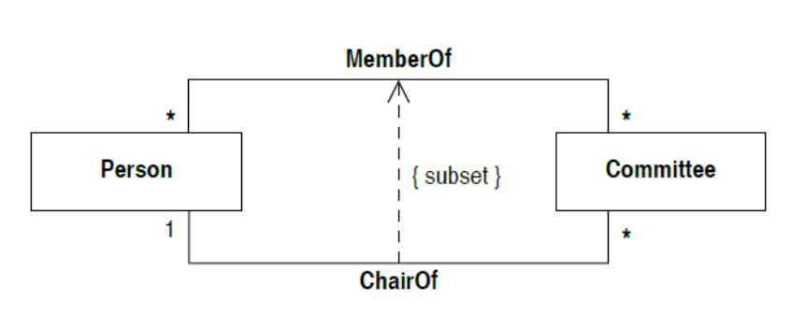

14. Given the C++ class hierarchy, answer (you may disregard any potential syntax or lexical errors):

1. Show object memory layout for XX, YY, and ZZ
2. Can the field `e` in YY and ZZ have different offsets? Explain.
3. How many distinct methods will be generated by the compiler? Name them using _Class_Method format?
4. Show memory layout just before `main` ends.

class XX{

int a = 10;

virtual int x() { return a; }

};

class ZZ : public XX{

int b = 20;

int e = 40;

int y() { a = a - b + e;

return a; }

};

class YY: public XX{

int y = 3;

int x = 5;

virtual int x() { return a + x; }

virtual int z() { e = a * y;

return a; }

};

int main () {

XX *p = new ZZ();

ZZ *r = new ZZ();

YY s;

XX t;

p->x(); r->x(); s.x(); t.x();

};

**Digital Logic & Number Systems**

15. Using 8-bit representation, express numbers 5 and -5 using:

1. Sign-Magnitude
2. One's Complement
3. Two's Complement.

16. Represent the number 76.8 using 32-bit floating point format.

17. Convert the decimal number 35.125 into:

1. Binary (base 2) number system
2. Octal (base 8) number system
3. Hexadecimal (base 16) number system.

18. Construct a logic circuit for a full adder using AND, OR, and NOT gates.

19. Convert the formula $F=\left(x_{1}∨x_{2}\overline{x_{2}}\right)\left(x_{1}∨x_{3}\right)$ into Disjunctive Normal Form (DNF) using equivalent transformations.

20. Using the rules of Boolean algebra, prove the following identity .

21. Write the corresponding input equations for the given sequential circuit.



22. Implement the function $F=ABC+\overline{A}BC+A\overline{B}C+A\overline{B}\overline{C}+\overline{A}\overline{B}\overline{C}$ using a 3-to-8 line decoder (DEC 3/8) and any additional necessary logic gates.

**Automata & Formal Languages**

23. Let the language be defined as L = { x ∈ {0,1}* | x ends with 1 and does not contain the substring "00" }. Write a regular expression that describes the language L.

24. Let L be the language consisting of all strings over the alphabet {0, 1} that contain an even number of 0s and an odd number of 1s. Draw a deterministic finite automaton (DFA) that recognizes the language L.

**Math & Misc**

25. In how many ways can we choose 8 cards from a deck of 52 such that:

1. Exactly 2 sevens and 3 aces
2. Exactly 2 sevens and at least 3 aces
3. At most 2 aces?

26. The voltage values measured at the output of the electrical circuit are shown in the table below. Determine the average voltage.

|  |  |  |  |  |  |  |
| --- | --- | --- | --- | --- | --- | --- |
| **Measurement No.** | 1 | 2 | 3 | 4 | 5 | 6 |
| **Voltage (V)** | 5 | 6 | 4.5 | 4.5 | 5.5 | 4.5 |
|  |  |  |  |  |  |  |

27. What is the absolute and relative error caused by rounding the number 𝑥=1.571 to two decimal places?